# CS 255 System Design Document Template

## UML Diagrams

### UML Use Case Diagram

### UML Activity Diagrams

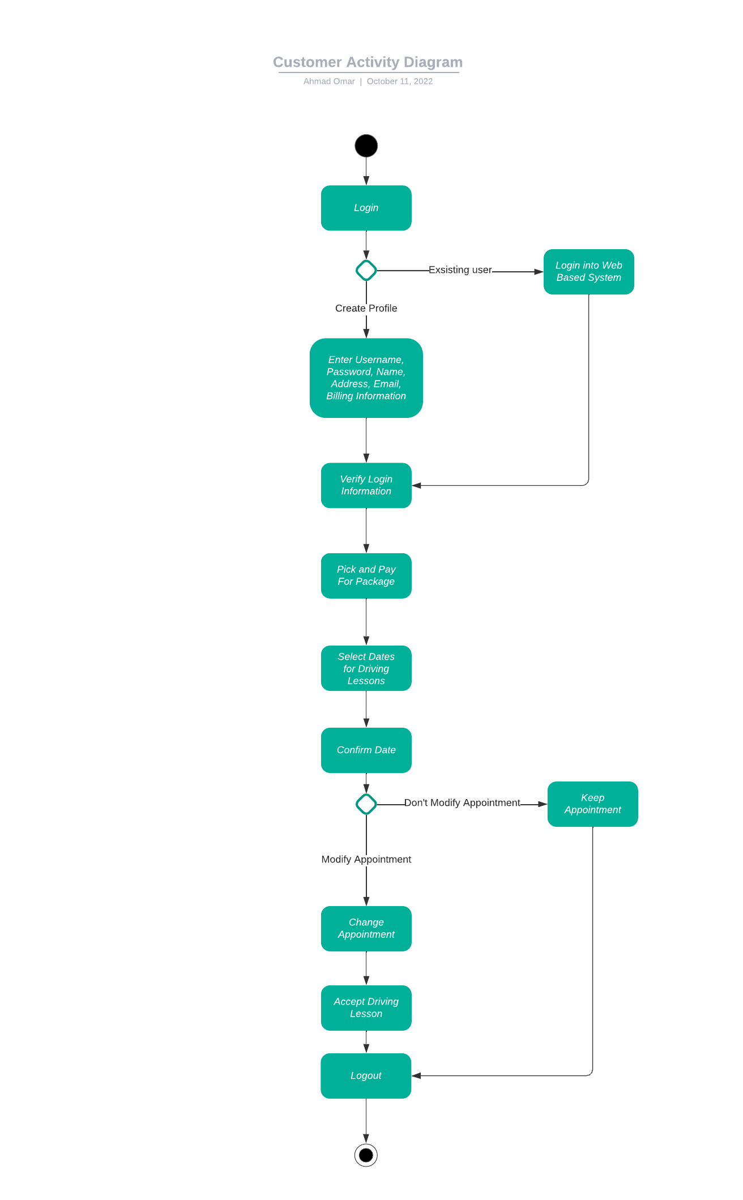

Project 2 Admin Activity UML Diagram


### UML Sequence Diagram

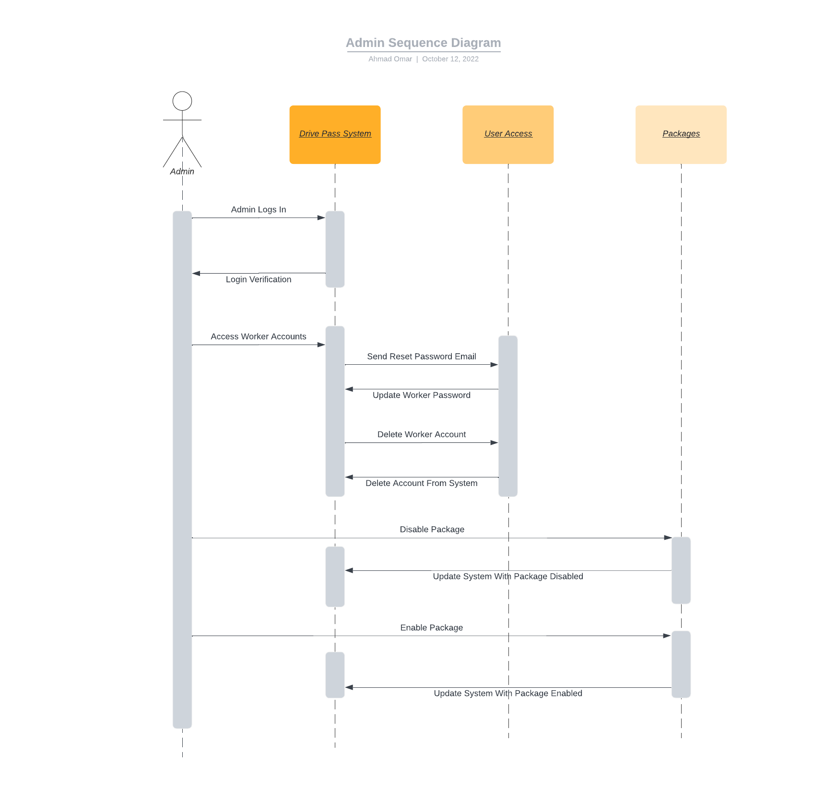

### UML Class Diagram

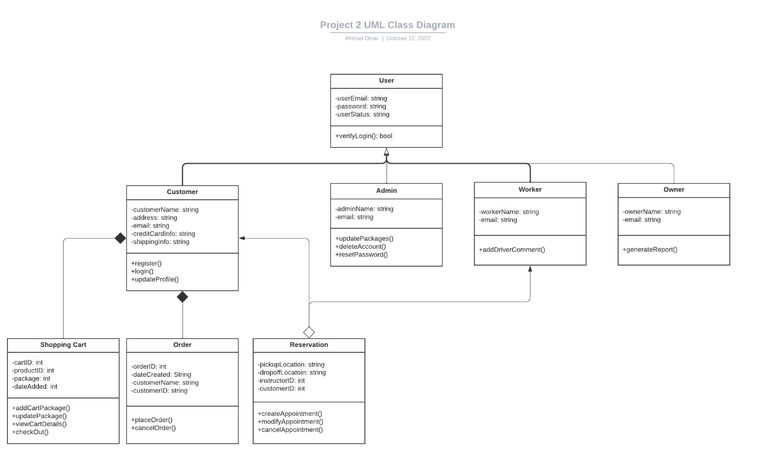

## Technical Requirements

**Hardware Requirements Client**

* No server is required since the client wants the system to be hosted on the cloud
* Use Internet to access cloud-based server
* Desktop or Laptops for Admin and Workers
* Monitor, keyboards, mouse to use desktop or laptop computers
* Internet provider for the business
* Ethernet connection or Wi-Fi connection to connect to the web-based system

**Hardware Requirements Customers**

* Desktop or Laptop or mobile device to access the web-based system
* Ethernet connection, Wi-Fi connection, or mobile data to access the system

The system will need a few things to function which is

* User Permissions
* Admins can disable or enable packages
* Admin’s being able to delete users and reset passwords for workers
* Admins must have full access to the system to make changes.
* Customers can create an account and sign up, if they already have an account they can log into the system
  + Customers can reset password without needed to reach out to system admins.
  + Customers can update their user profile to change information such as name, email address, home address, and billing information.
* Customers can select a package
  + Customer must have the ability to pay for the package
  + Customer can input credit card information
* Customer can create an appointment for diving lessons
  + They can also modify or cancel the appointment they made
* Workers can leave driver notes for the customer to view
* Web-based system will validate all users when they log in which is where it checks the user permissions, they have available